**Muhammad Bilal**

**Registration No: 04072113022**

**Web Application Development**

**V1.01**

### 

### Mission Statement

At Code Bridge, our mission is to create a user-friendly platform that simplifies the process of connecting software developers with companies seeking their expertise. We aim to empower companies to easily search for developers based on location and availability, providing them with the flexibility to find the right talent for their projects. Code Bridge connects you with elite talent quickly and efficiently. Say goodbye to lengthy searches and hello to instant access to the best tech talent around.

### Project Motivation

The idea behind Code Bridge is to make it easier for companies to find the right software developers for their projects. We want to simplify the process of connecting companies with talented developers by providing an intuitive platform where companies can search for developers based on location and availability. Our goal is to make the hiring process more efficient and accessible for both companies and developers, ultimately helping to foster collaboration and success in the tech industry.

### Audience

The audience for the Code Bridge website would primarily consist of two groups:

Companies: These are businesses or organizations in need of software developers or tech professionals for their projects. They could range from startups to large corporations across various industries.

Software Developers: These are individuals with expertise in software development, including but not limited to programmers, engineers, designers, and IT professionals. They may be seeking freelance opportunities or looking for full-time employment with companies using the platform.

In summary, the audience includes both companies seeking tech talent and software developers looking for job opportunities.

### Mind Map

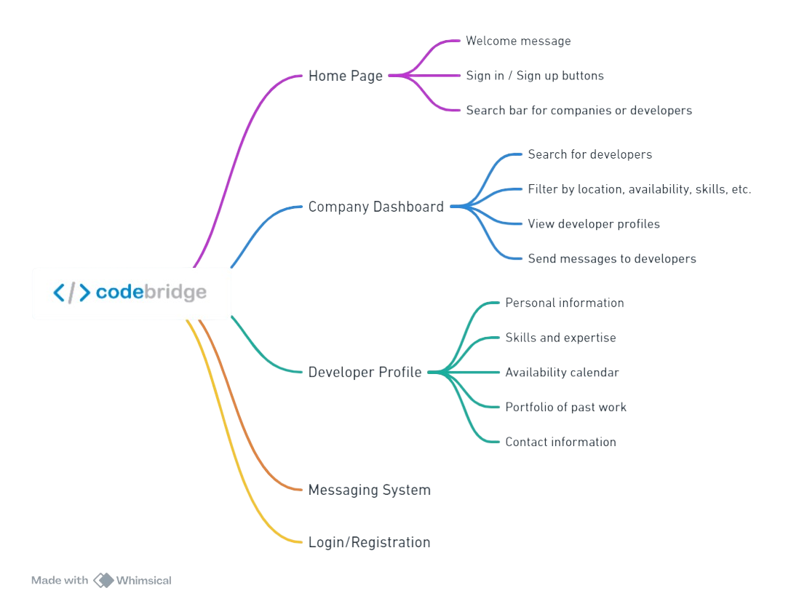

### Who, What and Where

Who:

Target Audience: Companies and software developers seeking freelance opportunities or employment in the tech industry.

What:

Purpose: Code Bridge serves as a platform to connect companies with skilled software developers, facilitating the hiring process and fostering collaboration in the tech industry.

Where:

Location: The website operates entirely online, accessible from anywhere with an internet connection.

Geographic Scope: Initially, the platform may target a specific region or country, with the potential to expand globally over time.

### URL

**codebridgepk.com**